R Portfolio Project

Bryan Burkey

MIS500 – Foundations of Data Analytics

Colorado State University – Global Campus

Dr. Mamdouh Babi

October 5, 2018

R Portfolio Project

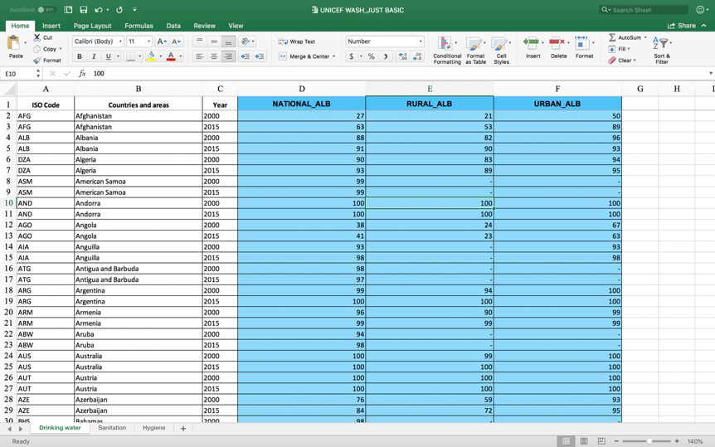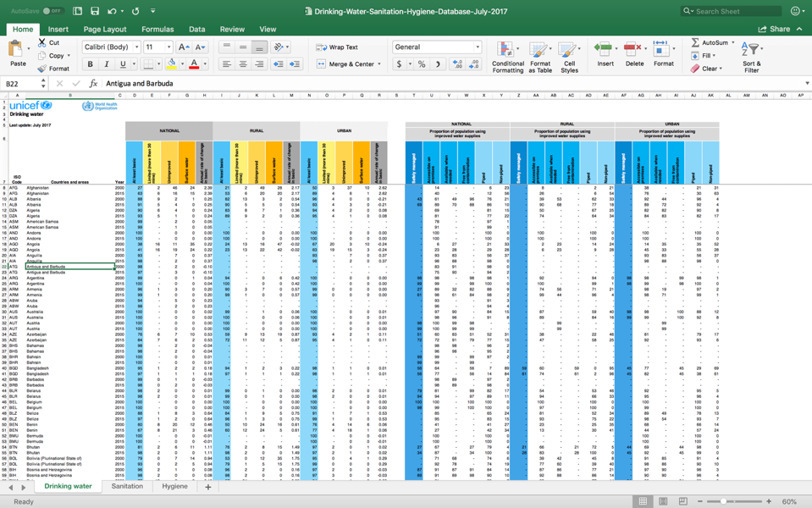I began this project by locating and downloading a dataset that contained data regarding the availability of safe drinking water around the world. I was able to locate JMP’s Water, Sanitation and Hygiene (WASH) dataset on UNICEF’s website (“Water, sanitation & hygiene,” 2017). This dataset included data on a multitude of categories of access to safe drinking water: *access to* *safely managed water services, at least basic drinking water, limited access, unimproved water, and surface water*. JMP, or Joint Monitoring Programme, is a joint effort between WHO (World Health Organization) and UNICEF (United Nations Children’s Fund), and works to provide regular global reports on safe drinking water availability to help support efforts and advocacy for improving access to safe drinking water globally (“WHO/UNICEF Joint Monitoring,” n.d.). JMP defines drinking water services as “the accessibility, availability and quality of the main source used by households for drinking, cooking, personal hygiene and other domestic uses” (“Drinking water,” n.d.). For the purposes of this project, I narrowed the scope of the dataset to only include *access to* *at least basic drinking water*, which JMP defines as “drinking water from an improved source, provided collection time is not more than 30 minutes for a roundtrip including queuing” (“Drinking water,” n.d.). After saving the dataset as a .csv file, I deleted some unnecessary/problematic introductory headers and deleted the columns that were unnecessary for the planned scope of the project, keeping the columns related to *access to* *at least basic drinking water (*or “*ALB”)* for National, Rural, and Urban area data, as well as *Country* and *Year* data columns.

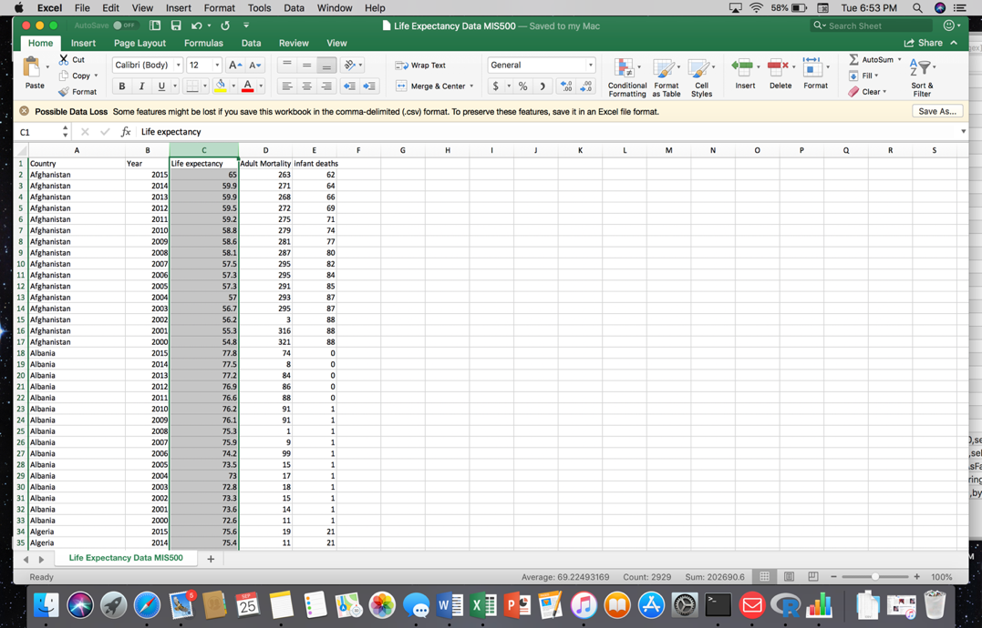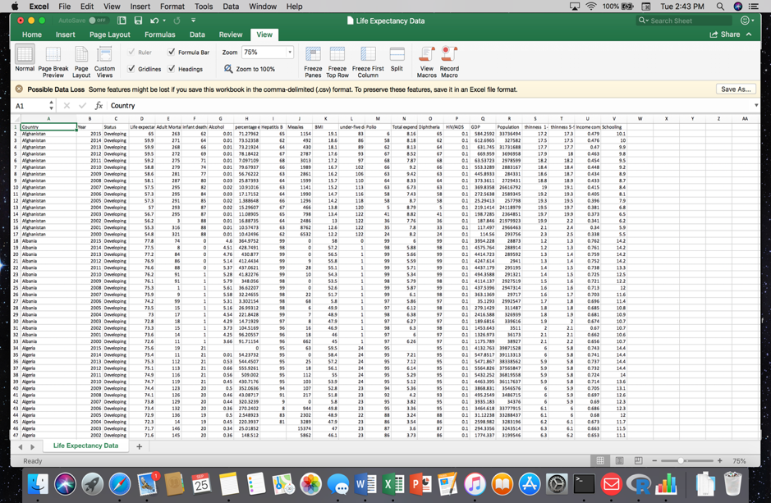I also wanted to include some other relevant data in my project to allow for a broader scope of analytics, so I researched and located a dataset created by Rajarshi (2018) based upon WHO (World Health Organization) data, that contained global life expectancy data, such as *number of infant deaths, adult mortality rate, life expectancy in years,* and *Country* and *Year* fields. As in the WASH dataset, this dataset contained columns that were unnecessary for the scope of my project, so I removed these from the .csv file before reading them into R Console:

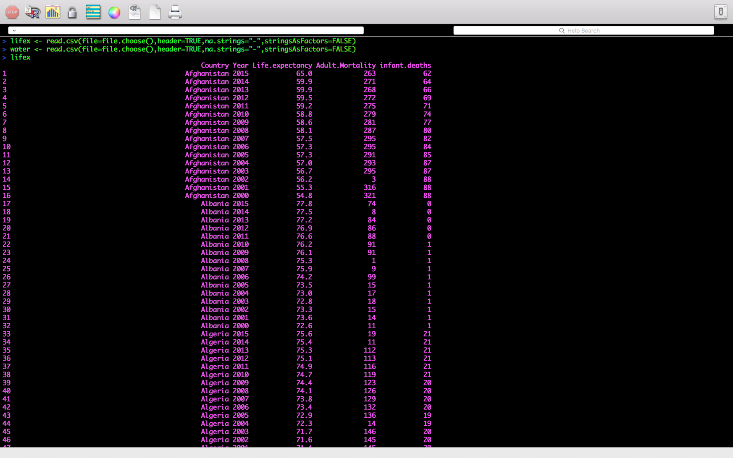I planned to join both the WASH dataset and the Life Expectancy dataset using the R **merge()** function, so I made certain that there was a column that was identical in both datasets to make a clean join/merge possible. In this case these would be the **lifex$Country** and **water$Country.and.areas**columns, and the **lifex$Year** and **water$Year** columns. I used the **read.csv()** function to import the two datasets into my R workspace separately, and then used the **merge()** function as follows:

**project <- merge(lifex,water,by.x=c("Country","Year"),by.y=c("Countries.and.areas","Year"))**

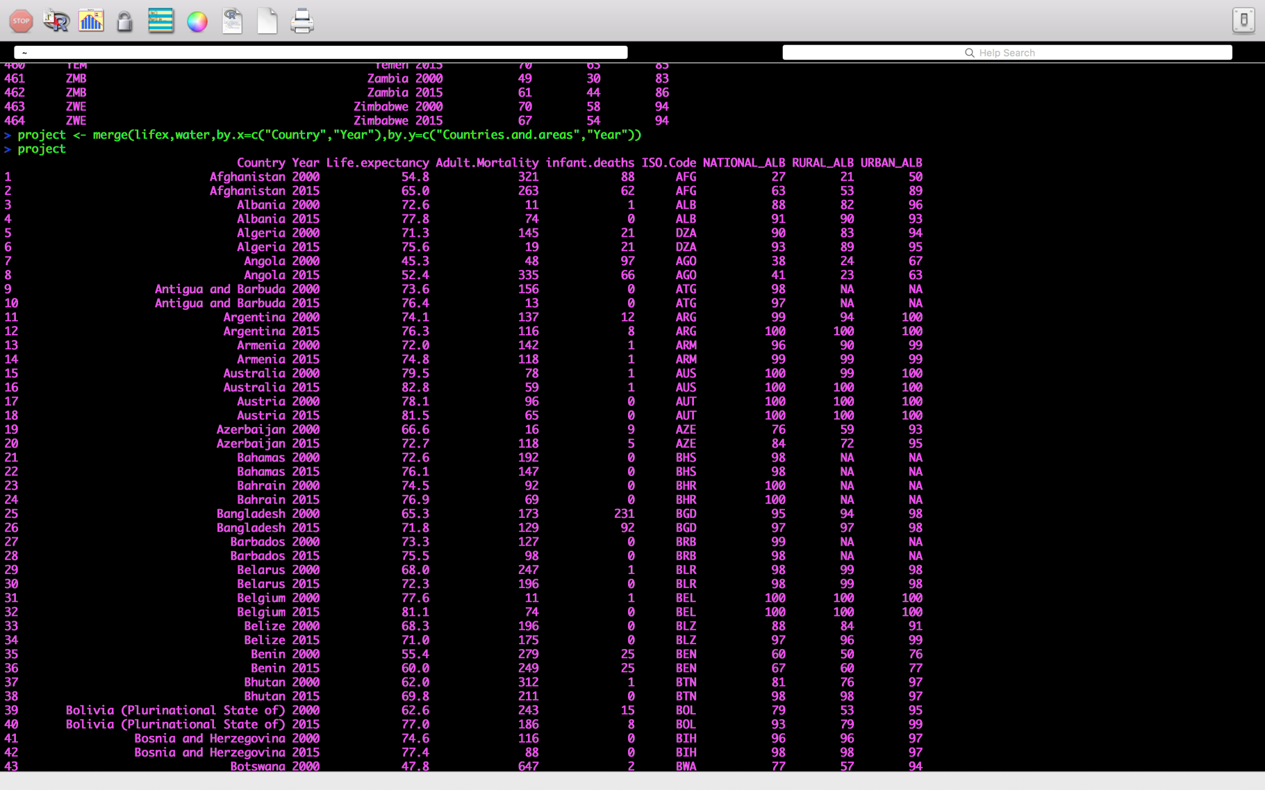Using the matching columns **lifex$Country** and **water$Countries.and.areas**, and the **lifex$Year** and **water$Year** columns, the two datasets merged nicely, correctly by country and correct matching year, keeping only the 2000 and 2015 year data:

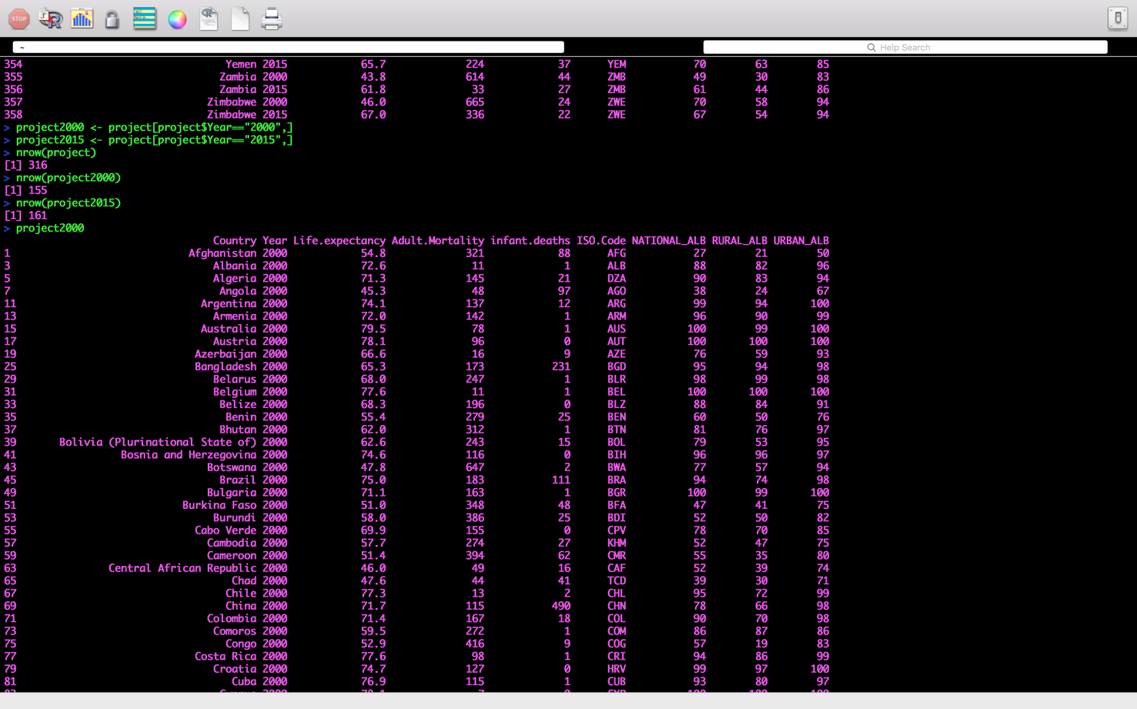I then used the **na.omit()** function to eliminate the few rows that contained **NA**’s. I wanted to create some subsets in order to more easily query the data and perform statistical operations, specifically a subset for the 2000 data and a subset for the 2015 data named **project2000** and **project2015**:

I created a couple additional subsets at this point. Using the **na.omit()** function, I had already removed all of the rows containing **NA**s. However, because the original datasets had a few countries without 2015 data, and other countries without 2000 data, in order to accommodate the analytics I had planned I needed a data.frame containing matching rows for all of the countries and for both years. So I created a **projectR2000** data.frame and a **projectR2015** data.frame, each with the exact same number of rows, matched by Country and Year,by removing the countries that did not have data for both 2000 and 2015. I used the 3-letter country ISO codes (**ISO.Code**)of the problematic countries in order to delete the necessary rows. I now had two equivalent data.frames, each having exactly 154 rows, one for 2000 data and one for 2015 data:

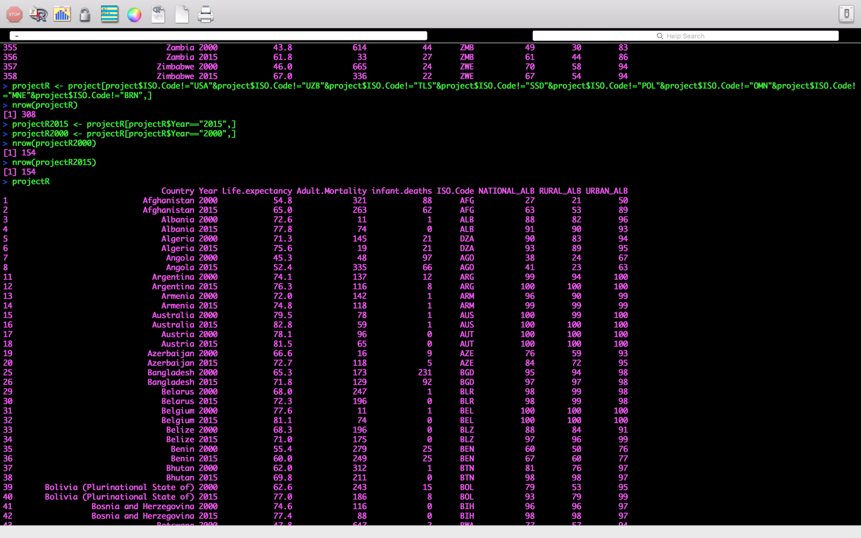

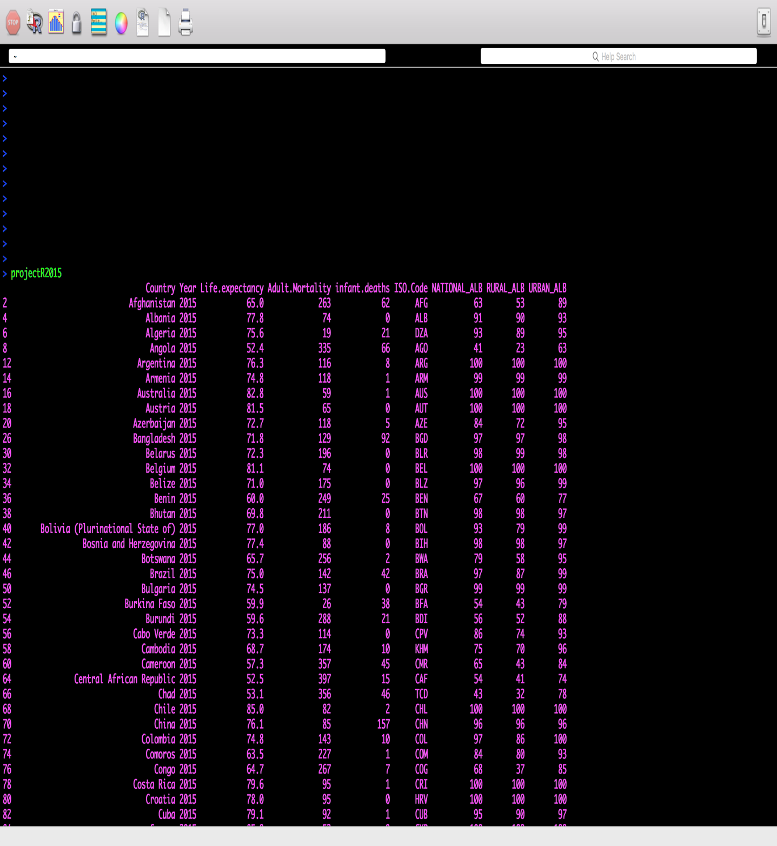

I saved the data.frames that I had created so far as .csv files to a folder on 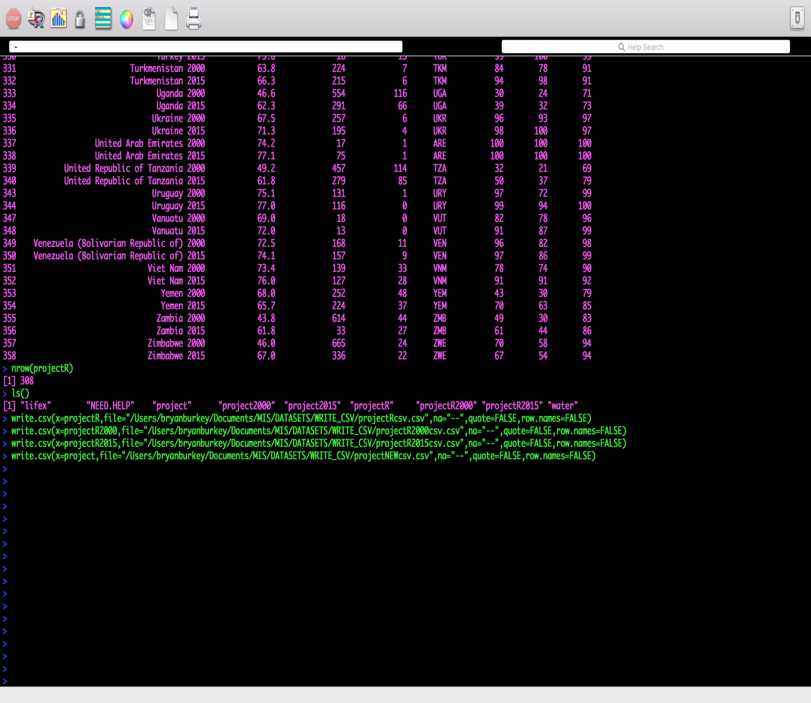my hard drive using the **write.csv()** function, making them available to access for future analytics projects:

Using the **write.csv()** function to create .csv files will also be helpful in using other programs such as Tableau to create visualizations using these data.frames that were created in R. Here is a screenshot of the folder containing all of the .csv files that were just created with **write.csv()**:

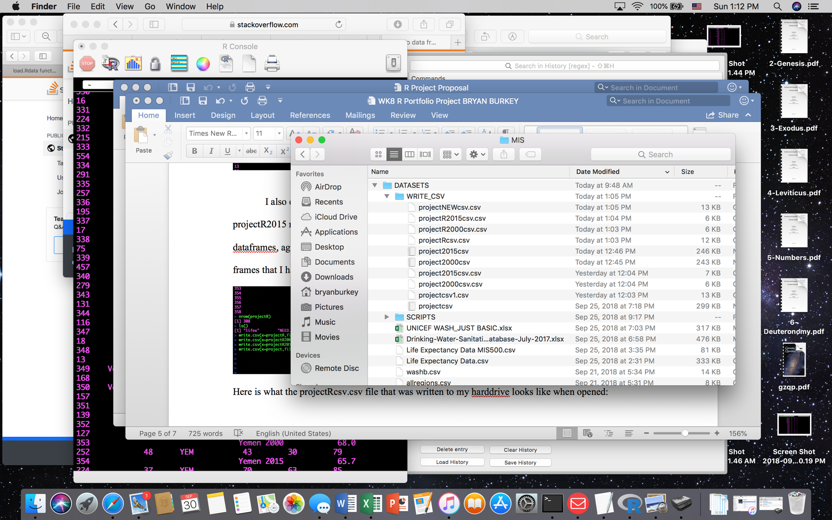

Here is a screenshot of the **projectRcsv.csv** spreadsheet for example, showing that the **write.csv()** command was successful:

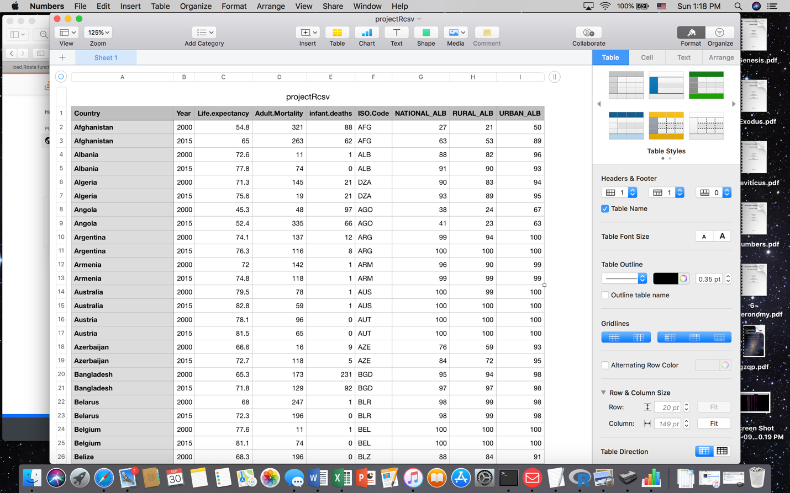

After creating the **projectR** data.frame subset, I was now able to create a new data.frame that I named **projectRC**. I wanted a separate data.frame to contain all of the most recent data (from 2015), with added comparison columns for each variable *versus* 2000, so that I could have a data.frame showing how each country has improved (or declined) from 2000 to 2015 with each measurement. I also renamed the columns to more abbreviated names so that the column widths allowed for better viewing of all columns all at once on the screen in R Console. I accomplished all of this by writing the following code:

**colnames(projectRC) <- c("Country","Year","LfEx15","AdMort15","infantd15","ISO","Nalb15","Ralb15","Ualb15")**

#changes column names

**projectRC$Nalb15vs00 <- projectR2015$NATIONAL_ALB-projectR2000$NATIONAL_ALB**

#creates a new column and places the value of the difference between 2000 and 2015 data

**projectRC$Ralb15vs00 <- projectR2015$RURAL_ALB-projectR2000$RURAL_ALB**

#creates a new column and places the value of the difference between 2000 and 2015 data

**projectRC$Ualb15vs00 <- projectR2015$URBAN_ALB-projectR2000$URBAN_ALB**

#creates a new column and places the value of the difference between 2000 and 2015 data

**projectRC$LfEx15vs00 <- projectR2015$Life.expectancy-projectR2000$Life.expectancy**

#creates a new column and places the value of the difference between 2000 and 2015 data

**projectRC$AdMort15vs00 <- projectR2015$Adult.Mortality-projectR2000$Adult.Mortality**

#creates a new column and places the value of the difference between 2000 and 2015 data

**projectRC$infantd15vs00 <- projectR2015$infant.deaths-projectR2000$infant.deaths**

#creates a new column and places the value of the difference between 2000 and 2015 data

**colnames(projectRC) <- c("Country","Year","LfEx15","AdMort15","infantd15","ISO","Nalb15","Ralb15","Ualb15","NalbC","RalbC","UalbC","LfExC","AdMortC","infantdC")**#changes the column names of the newly created columns to be shorter to aid with easier viewing of the projectRC data.set on screen

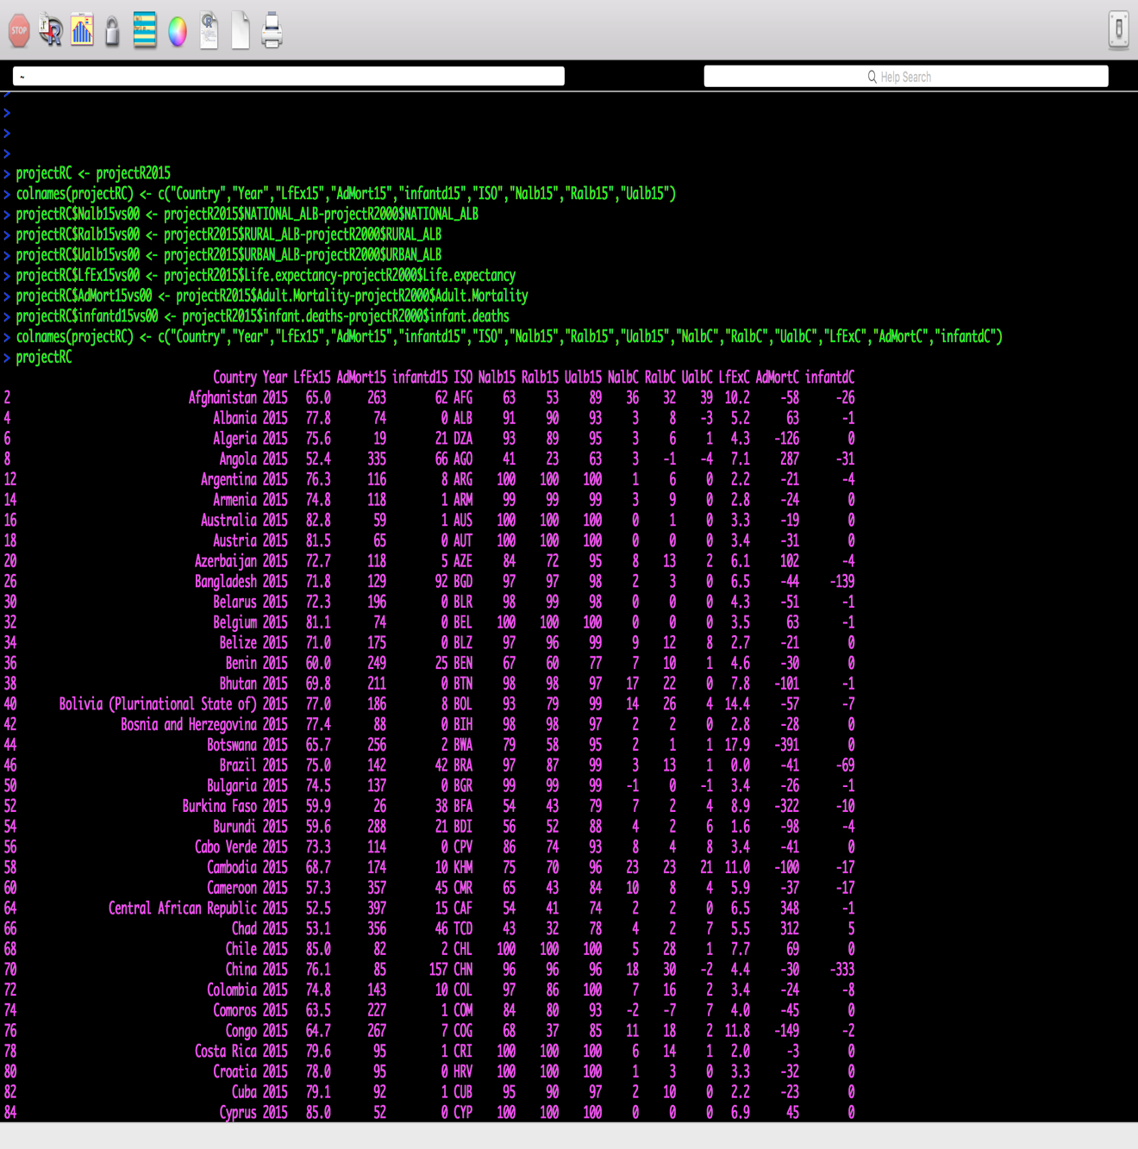

At this point I had constructed all of the data.frames that I needed to proceed with some analytics. As I was processing the data (ie. creating various subsets, calculations, etc), I wrote down some of the thoughts and questions that I had regarding the data, which gave me some guidance as to what type of analytics I would conduct. The primary influence upon my thoughts and questions regarding these datasets, and the nature of my analytics, came from a quote on UNICEF’s Water and sanitation overview page:

Inadequate drinking water, sanitation and hygiene (WASH) remains a leading cause of child deaths. It is also responsible for a major share of the global burden of childhood diseases and malnutrition – which in turn impact a child’s overall development, learning opportunities, and ultimately their prospects of a fair chance in life. Access to water, and sanitation and hygiene is thus fundamental to sustainable development. (Water, Sanitation and Hygiene, 2017)

Thus, my purpose for performing analytics upon UNICEF’s WASH dataset, along with WHO’s Life Expectancy dataset in this project, is to articulate the nature of this global burden using the R and Tableau tools to answer some of these questions:

* Which countries have the most inadequate access to at least basic drinking water (most urgent need)?
* Are there countries in all four of these bottom quartiles?
* Which countries are in the bottom quartile for access to at least basic drinking water?
* Which countries are in the bottom quartile for life expectancy? Adult mortality? Infant Deaths?

To help answer these questions I began by using the **quantile()** function, and selected the lower *quartiles* to find the countries in the most need of improved water services:

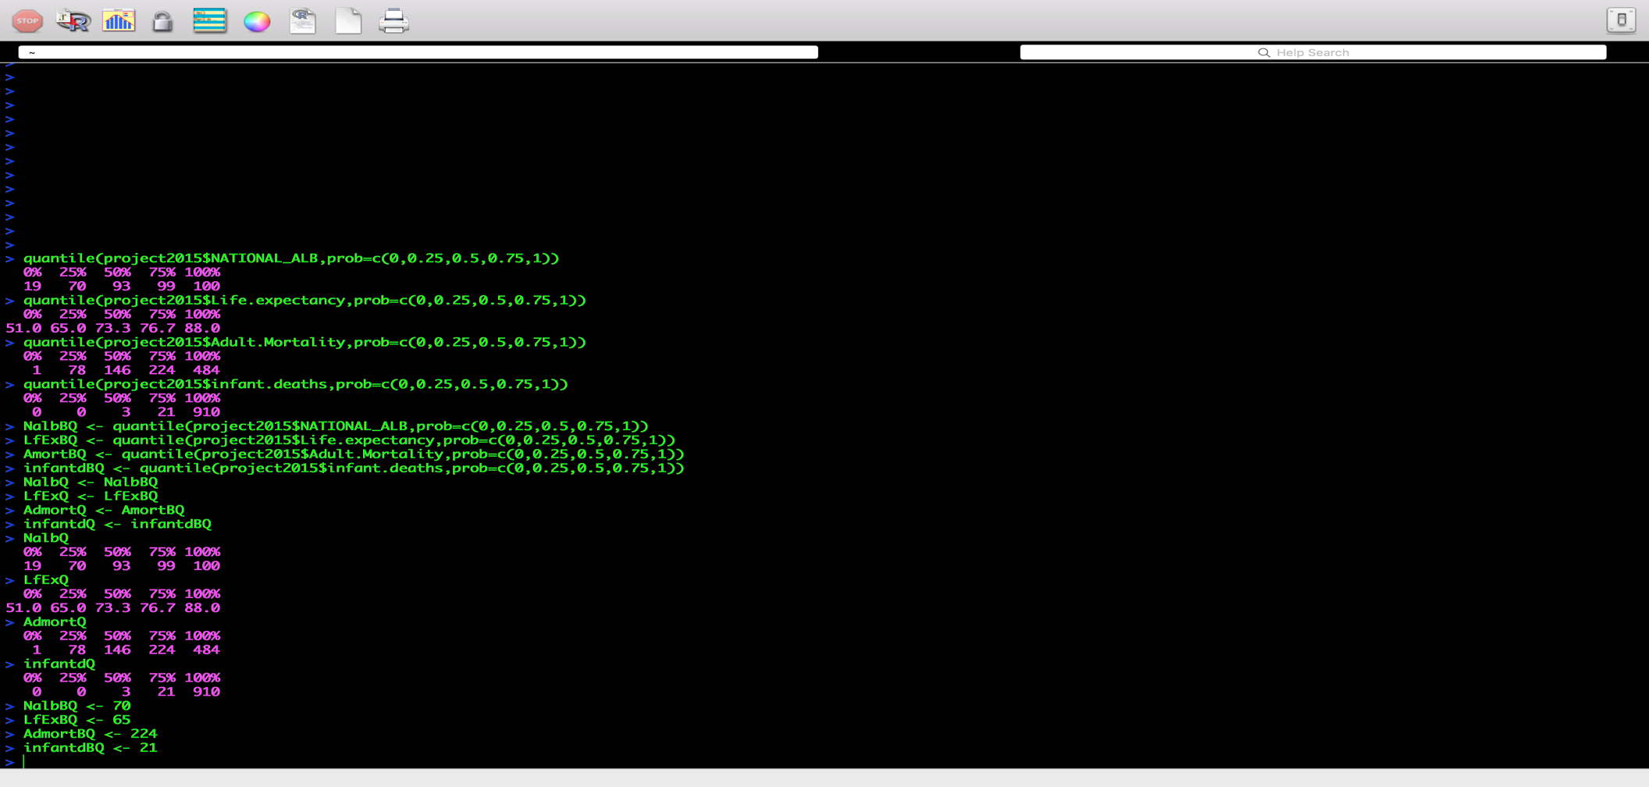

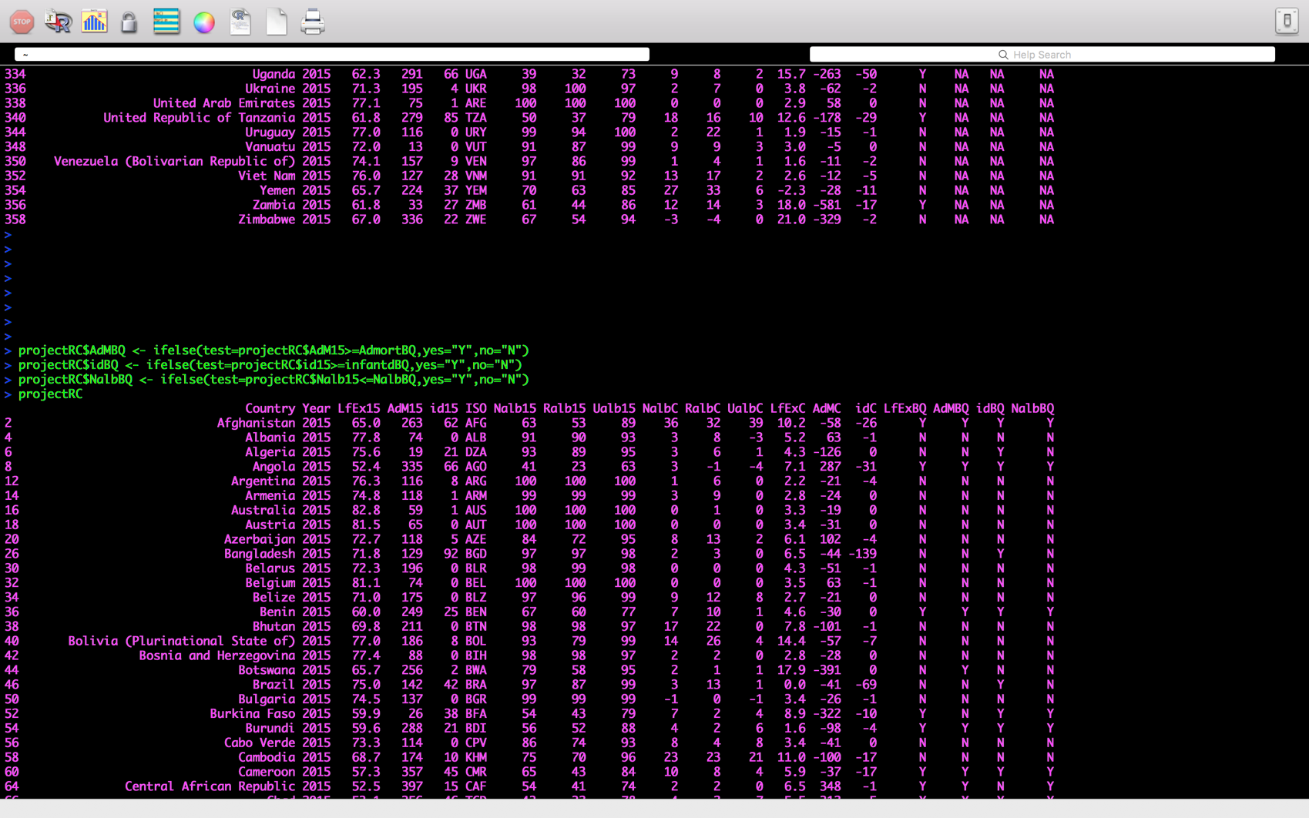After changing the column names using the **colnames()** function, I created additional columns that stored a “Y” or “N” using the **ifelse()** function by looking at each value in Nalb15 (national average access to at least basic drinking water services in 2015), LfEx15 (average life expectancy in years in 2015), AdM15 (adult mortality defined as number of deaths per 1000 population between 15 and 60 years old in 2015), and id15 (number of infant deaths per 1000 population in 2015) and comparing these values with the lower quartiles that I had calculated with the **quantile()** function. Using the **ifelse()** function, each value in each variable column was compared with the related lower quartile for each, and a “Y” was placed if that value fell in the lower quartile, and an “N” if it did not:

These columns would be helpful for quickly identifying which countries fell in the lower quartile (in most urgent need of help) for each category. These newly created columns also enabled me to easily create some effective visualizations using Tableau Public:

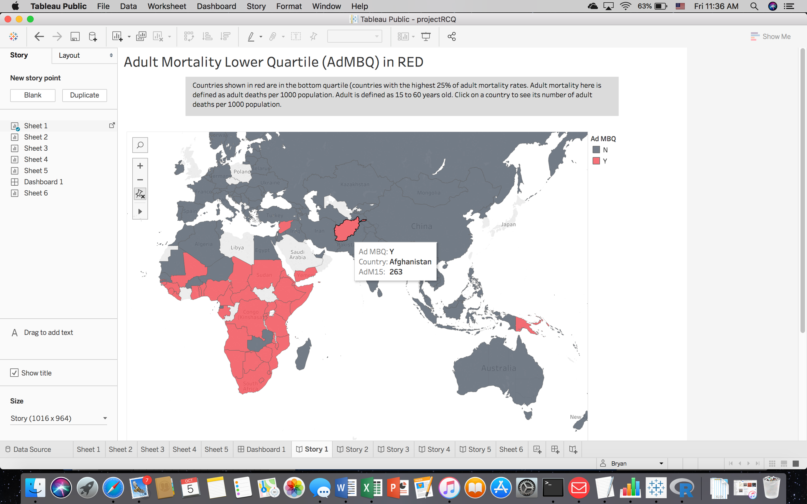

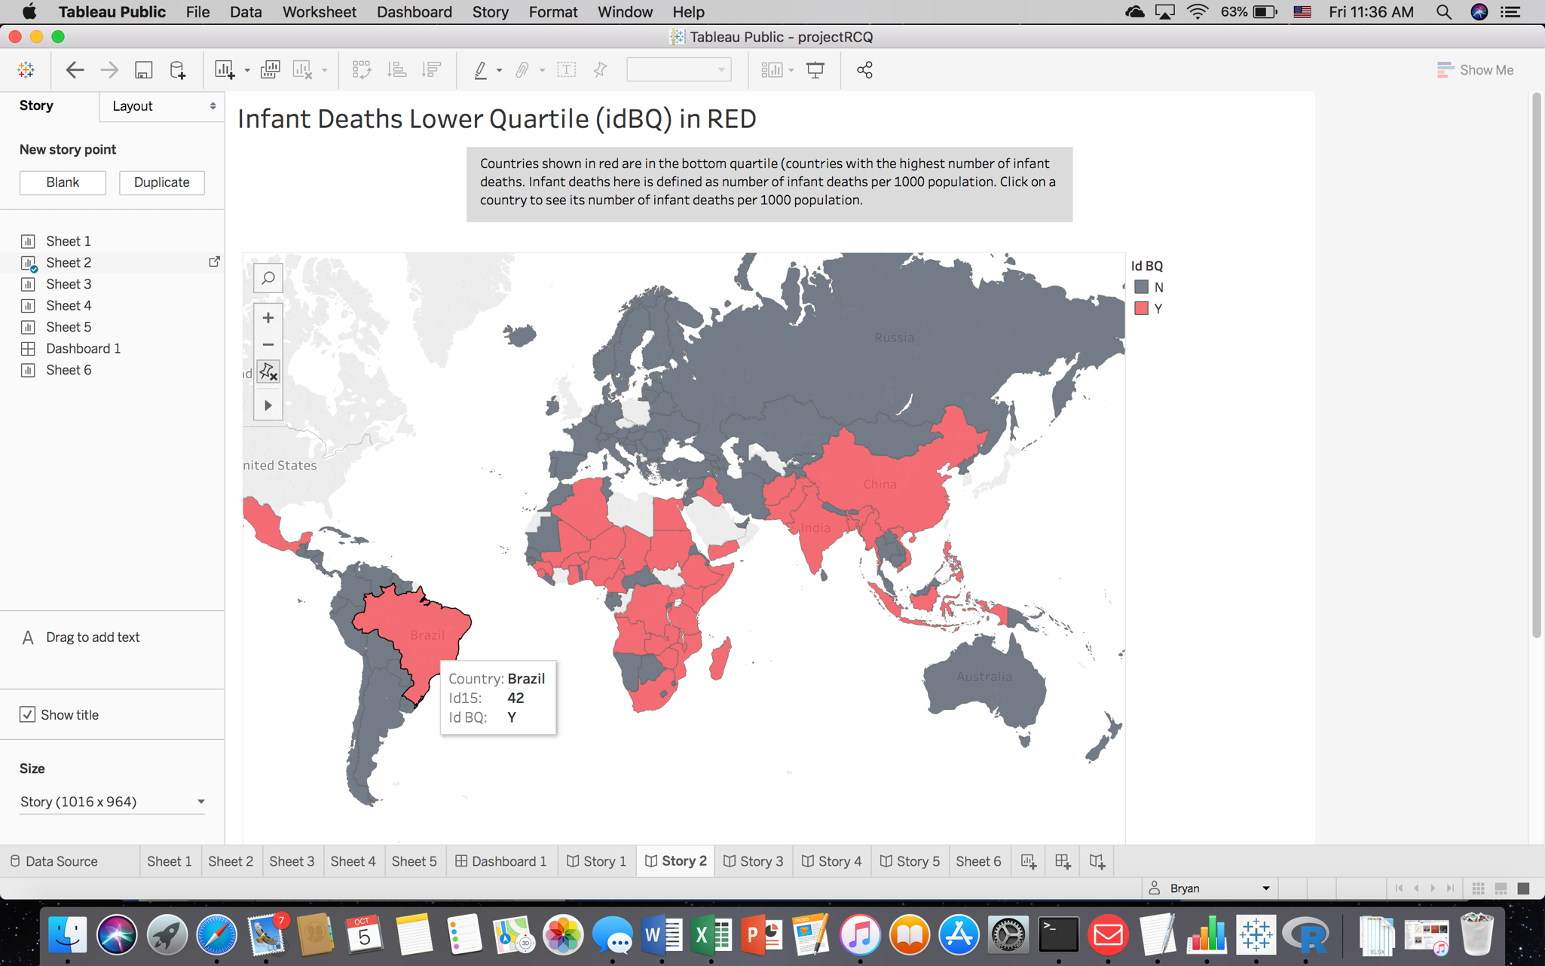

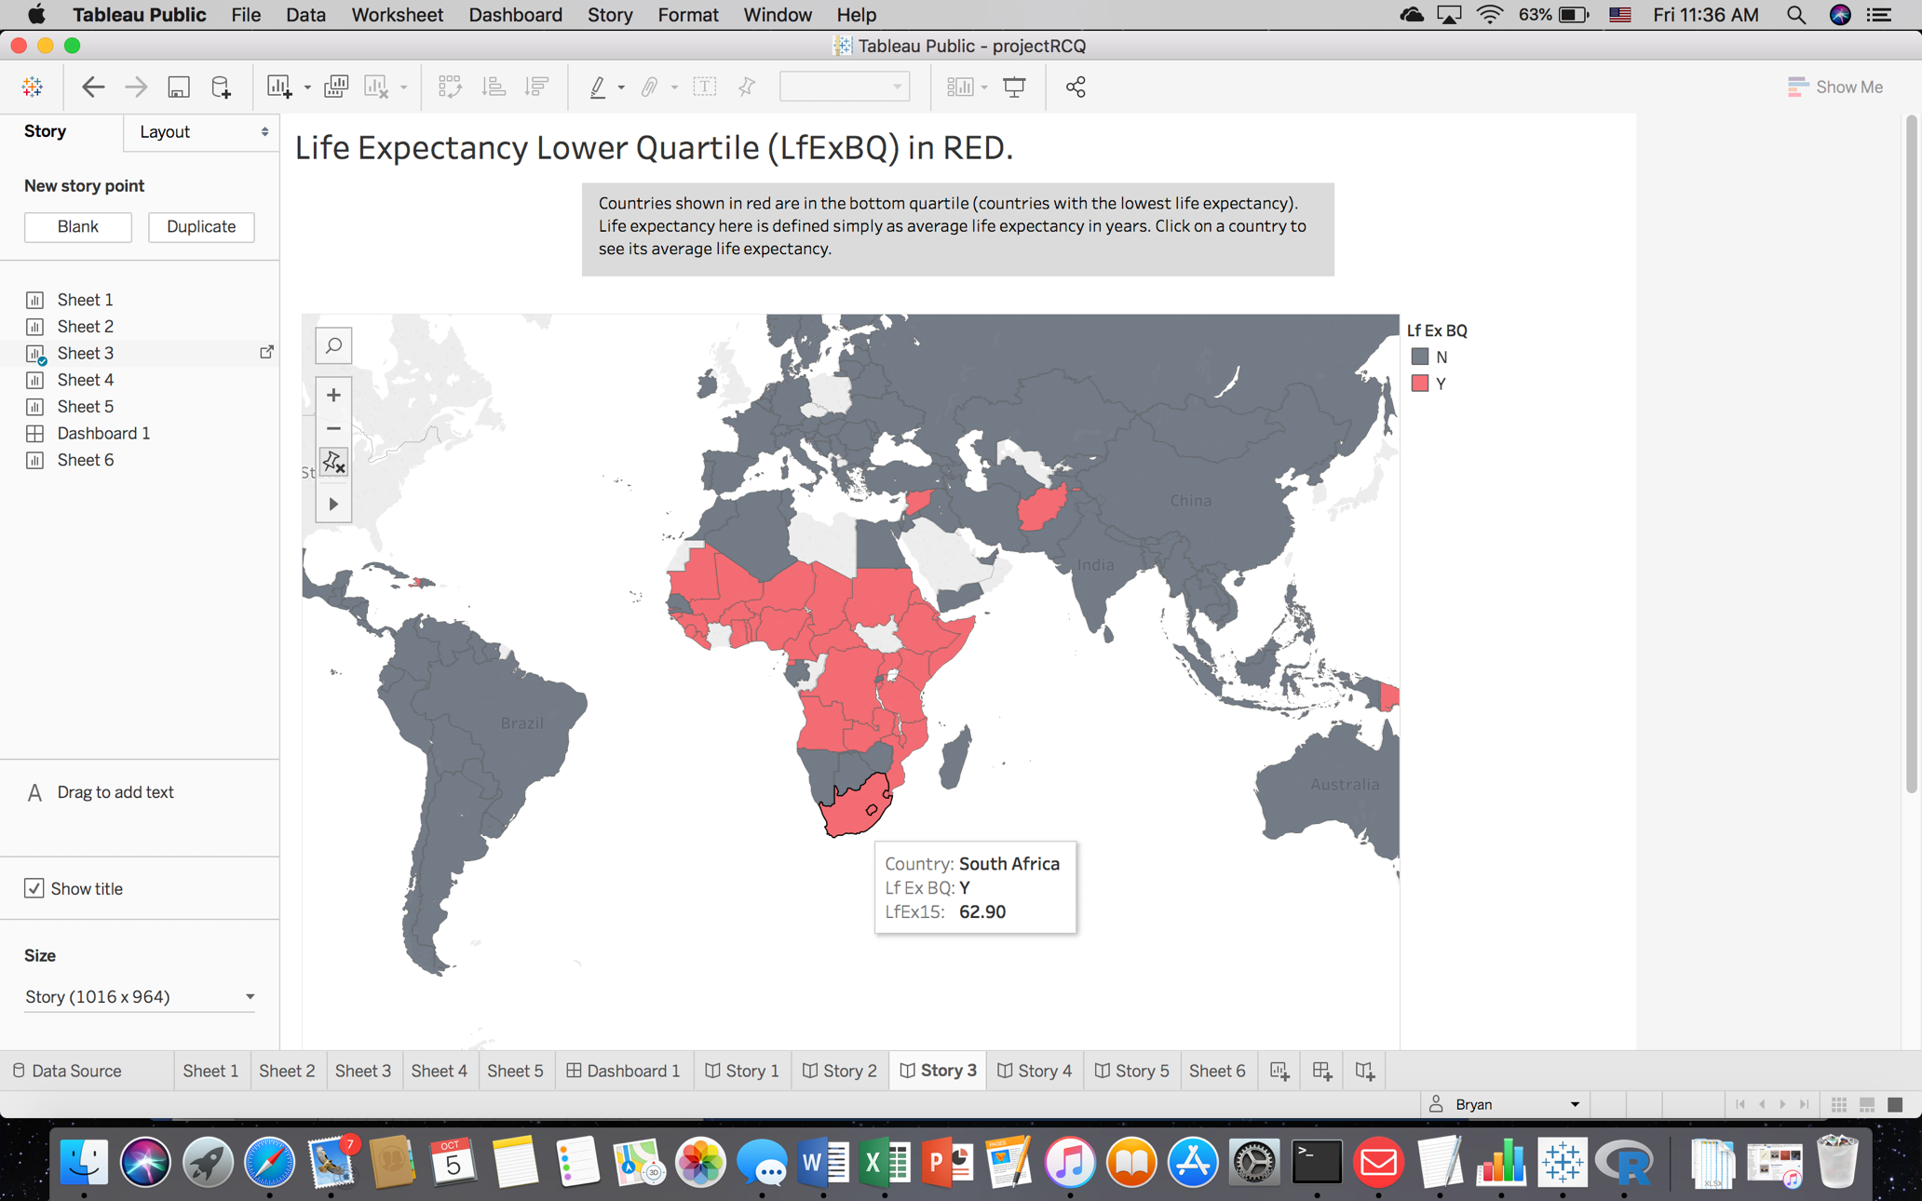

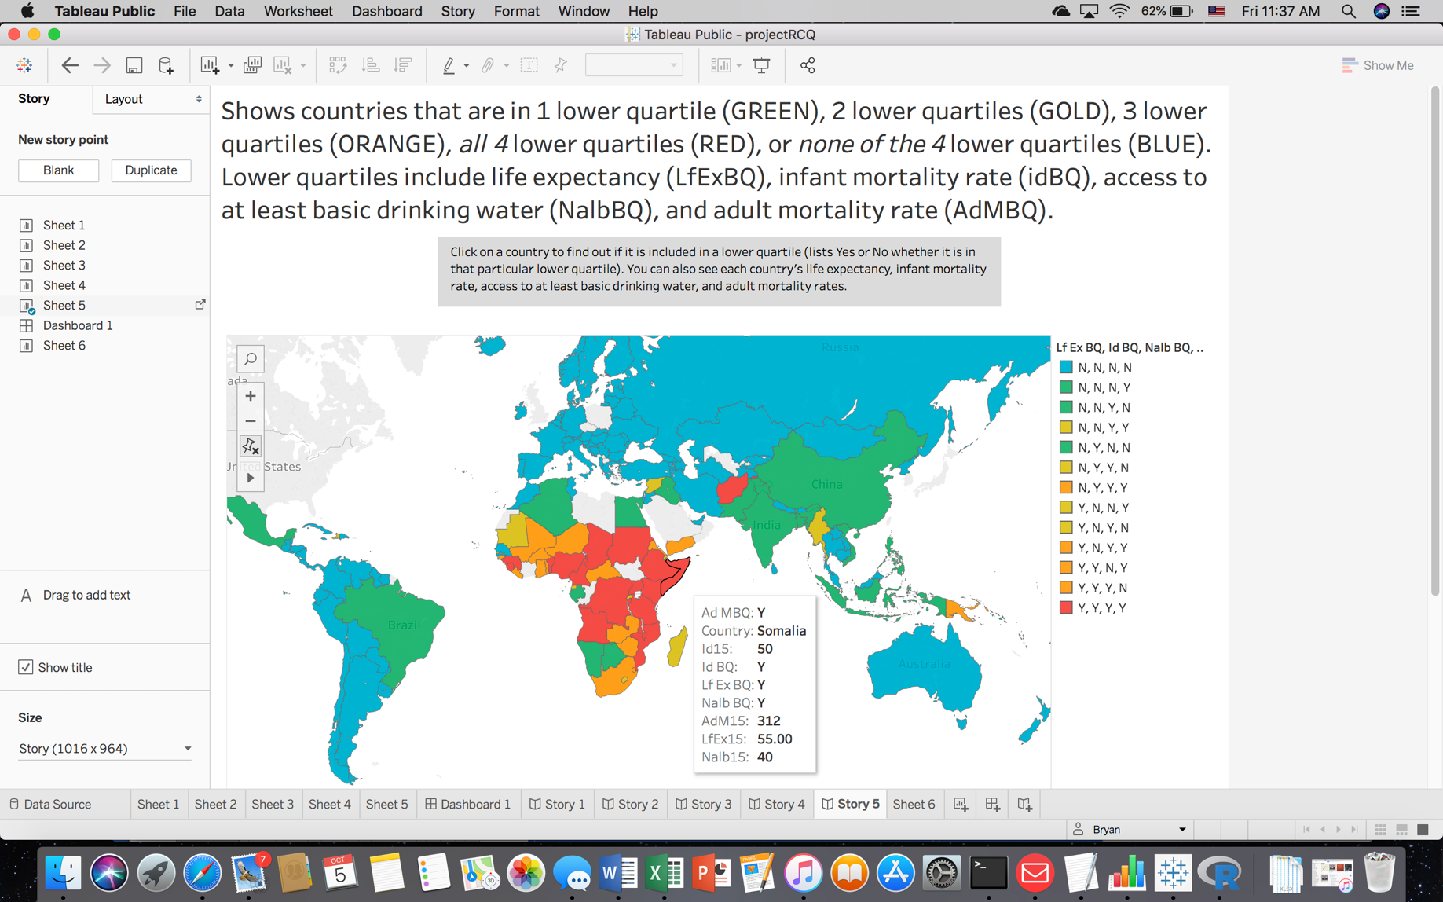

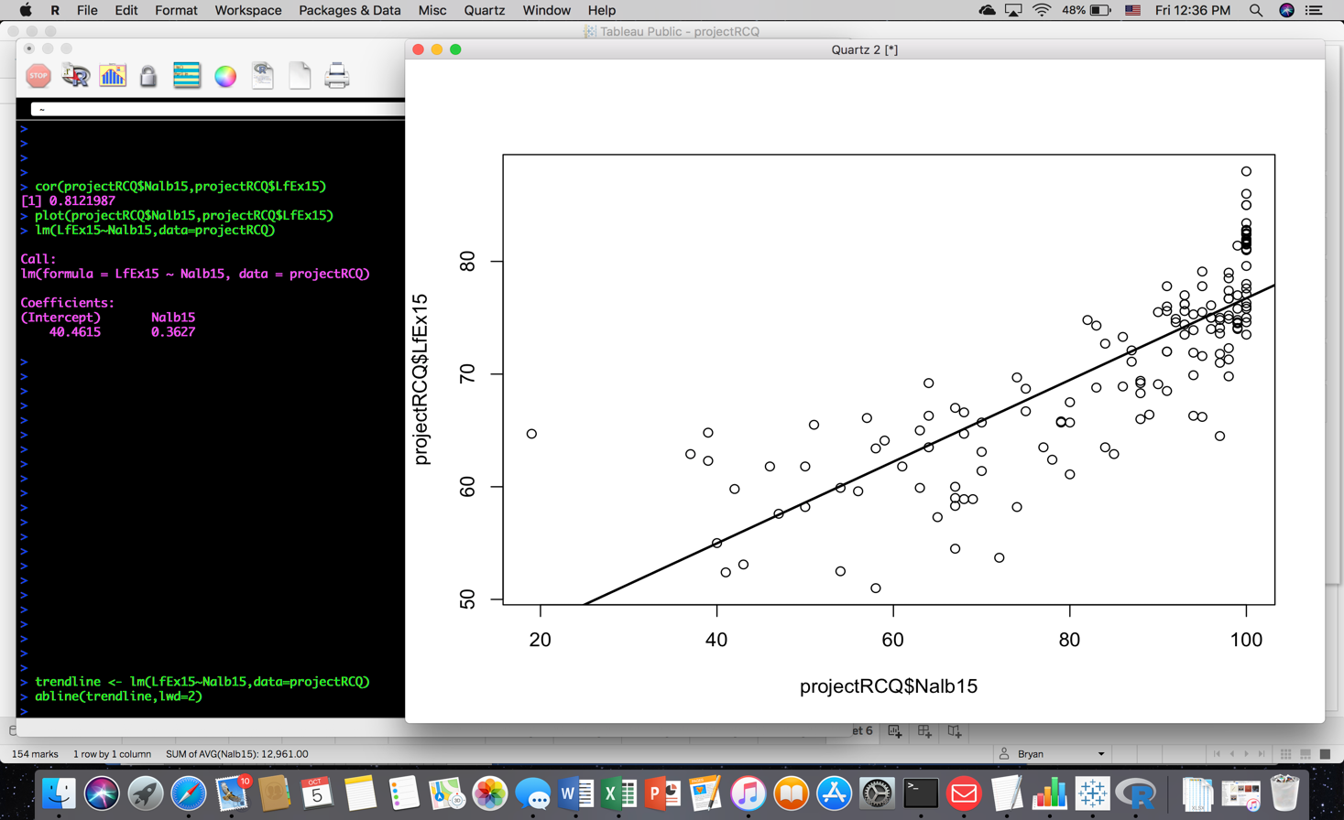Another question that arose as I was exploring the data asked, “Is there correlation between poor access to drinking water and life expectancy?” To explore this question, I used the **cor()** function in R, which showed a strong correlation between these two variables of **0.8121987**. To help illustrate this correlation I used R and Tableau:

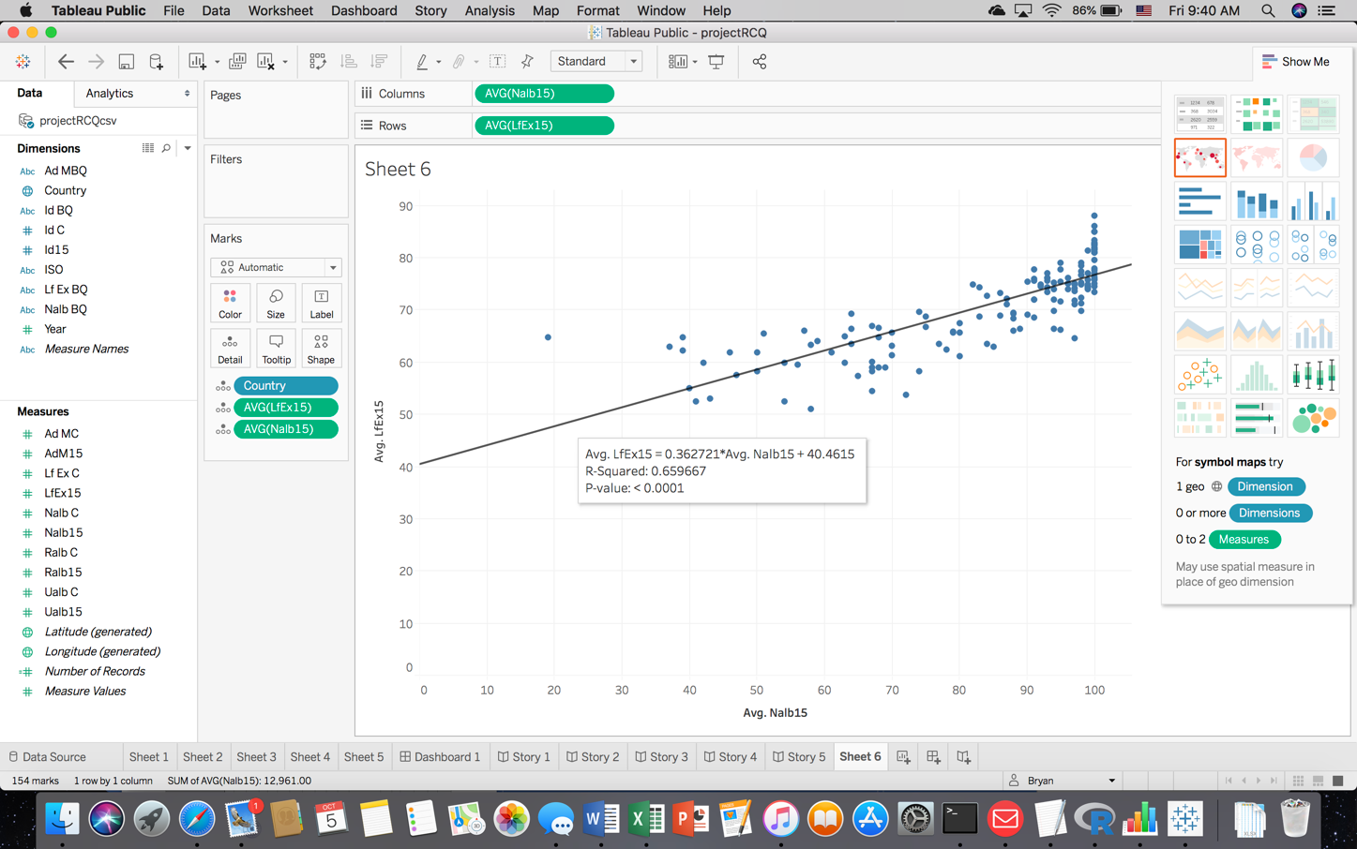

Using the **lm()** and **abline()** functions in R, and the Trend Line option in Tableau, both revealed the same estimated linear model, showing that on average, for every 1 percent increase of **Nalb15** (at least basic access to drinking water), a country’s average life expectancy is estimated to increase by 0.362 years.

I also wondered if any countries had “graduated” out of the lower quartile to a higher (improved) quartile from 2000 to 2015. If so, these countries could provide clues to other struggling countries as to which methods of improving access to drinking water have the most success historically. To explore this question, I created columns in the **projectR2000** data frame as I did for **projectRC** (using **projectR2015**), that showed whether (“Y”) or not (“N”) countries were in the lower quartile for each variable (life expectancy, basic access to drinking water, infant deaths, and adult mortality) using the same names as in **projectRC**: (**LfExBQ**, **NalbBQ**, **idBQ**, and **AdMBQ**, respectively). I then used code to compare these columns from the 2000 data.frame to the matching columns in the 2015 data.frame, and created four *new* columns that showed whether (“Y”) or not (“N”) a country had “graduated” out of the lower quartile to a higher quartile by the year 2015:

**projectR2000$grad2015 <- ifelse(test=projectR2000$LfExBQ=="Y" & projectRCQ$LfExBQ=="N",yes="Y",no="N")**

**projectR2000$gradAM <- c("NA")**

**projectR2000$gradid <- c("NA")**

**projectR2000$gradALB <- c("NA")**

**projectR2000$gradAM <- ifelse(test=projectR2000$AdMBQ=="Y" & projectRCQ$AdMBQ=="N",yes="Y",no="N")**

**projectR2000$gradid <- ifelse(test=projectR2000$idBQ=="Y" & projectRCQ$idBQ=="N",yes="Y",no="N")**

**projectR2000$gradALB <- ifelse(test=projectR2000$NalbBQ=="Y" & projectRCQ$NalbBQ=="N",yes="Y",no="N")**

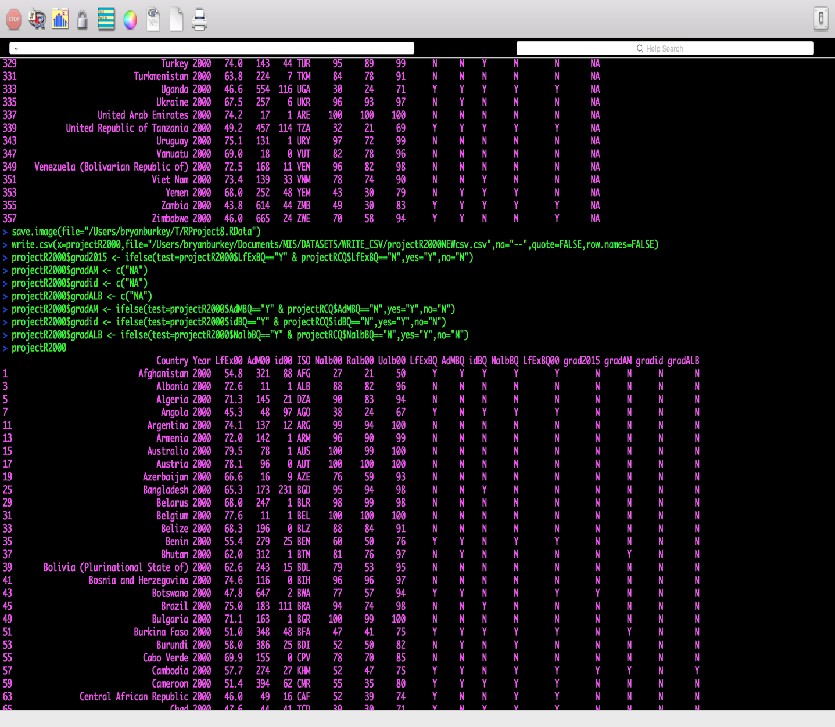

A quick query in R Console (also creating a new data.frame named **graduates2015**), shows all of the countries that graduated out of a lower quartile(s) from 2000 to 2015:

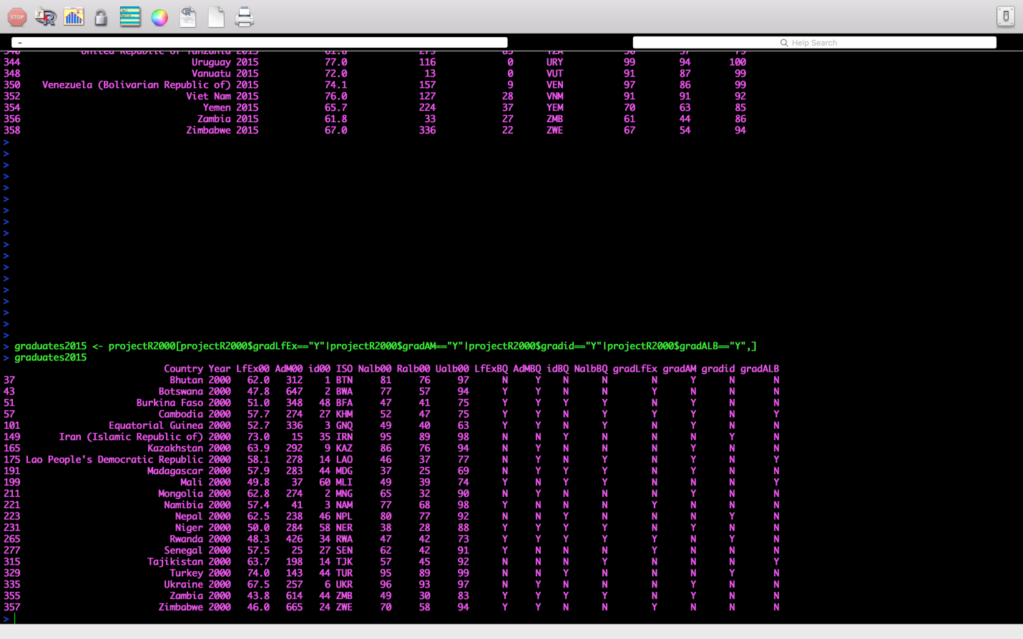

I also wanted to know, “Of the countries in the bottom quartile for access to basic drinking water services, which countries showed significant improvement from 2000 to 2015?” And which countries showed little to no improvement? I used the comparison columns that I created in the **projectRC** data.frame (with calculated gains or losses of percentage access to drinking water from 2000 to 2015). These comparison columns are also included in the **projectLQ.Nalb15** data.frame:

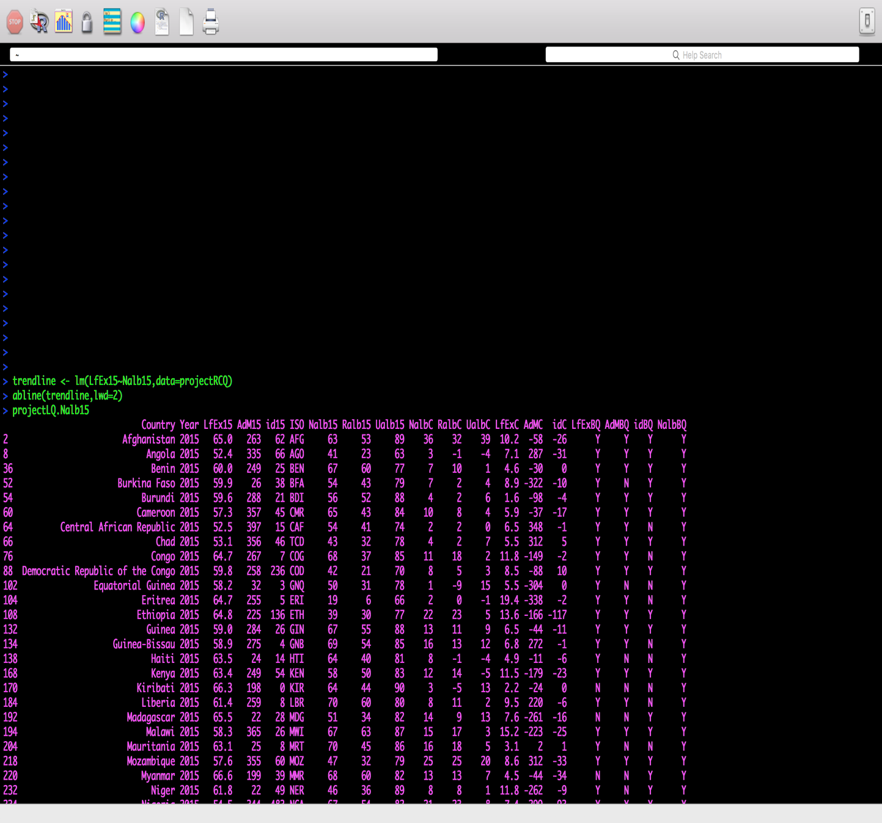

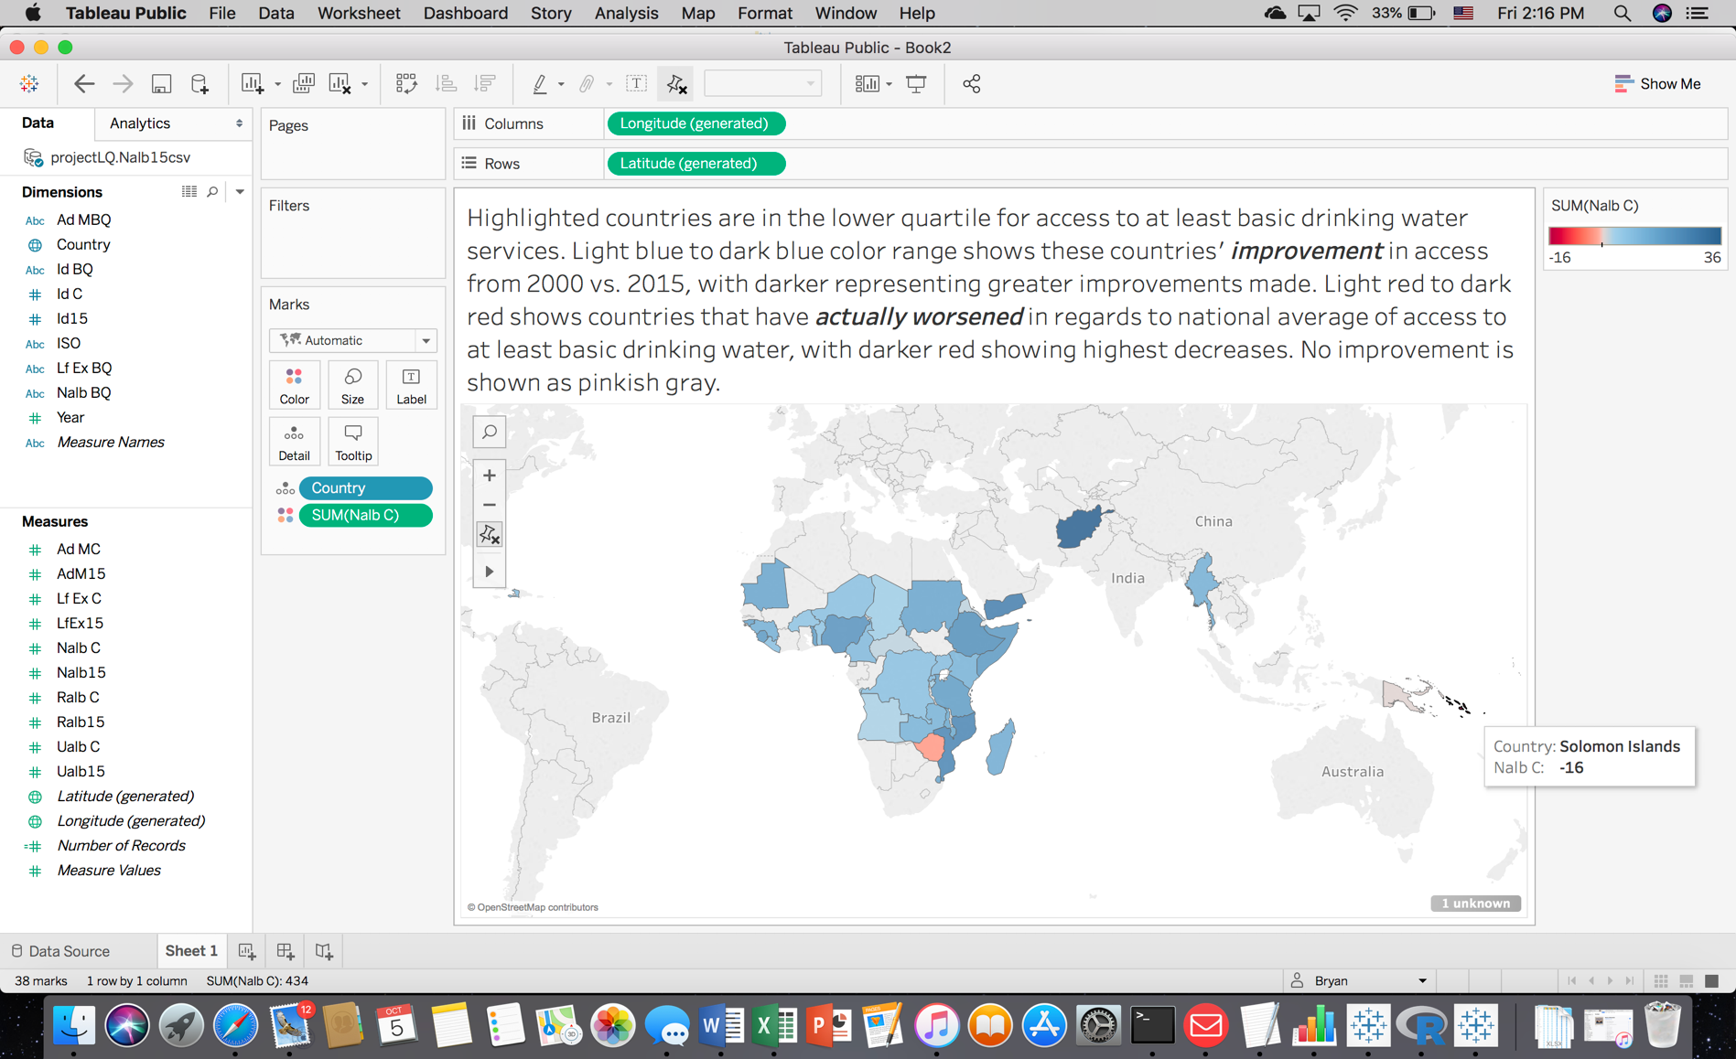I saved this data.frame as a .csv to a folder on my computer so that I could use it in Tableau to visualize how the lower quartile countries are doing today compared to 2000 (numbers here represent percentage changes in national average basic access to drinking water):

And finally, I concluded this project with a broader question, “Has there been significant improvement, overall, in access to at least basic drinking water from 2000 to 2015 throughout the globe?”

To answer this final question, I will write it in the form of a hypothesis:

**H0 : 𝜇projectRC$Nalb15 - 𝜇projectR2000$Nalb00 = 0**

**HA : 𝜇projectRC$Nalb15 - 𝜇projectR2000$Nalb00 > 0**

To conduct a hypothesis test on these two unpaired/independent samples, I used the **t.test()** function in R to conduct a pooled variance t.test:

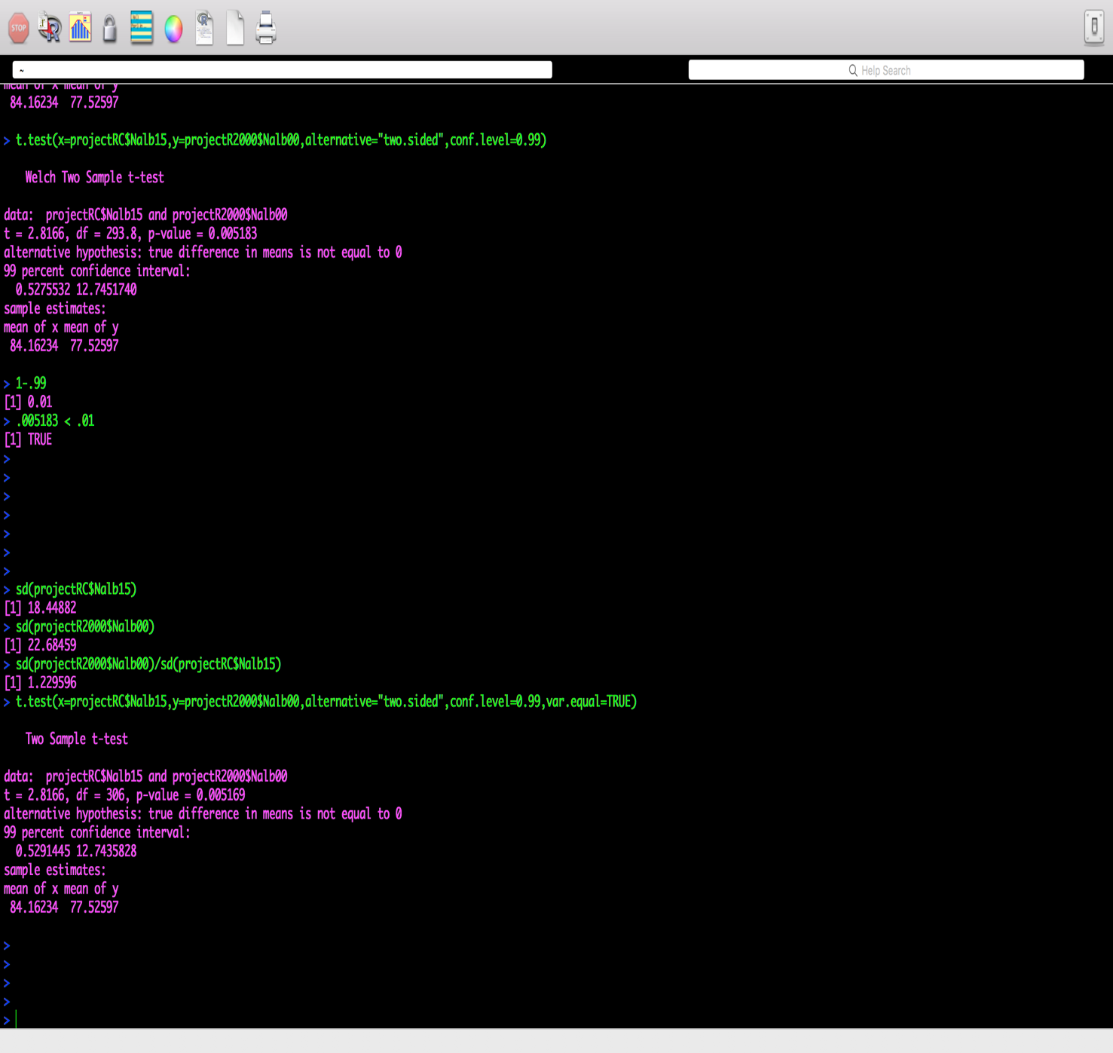

Therefore, I am 99% confident that the true difference in mean basic access to drinking water between 2015 and 2000 is somewhere between positive 0.529 percent change in access and positive 12.7 percent change in access, thus rejecting the null hypothesis. Because “zero isn’t included in the interval, and that the interval is wholly positive” (Davies, 2016), the results of this t.test supports the conclusion of the alternative hypothesis.

**Conclusion**

At the conclusion of this project, I have experienced firsthand how data analytics can extract meaningful, and even actionable information from just a couple of datasets. Using R’s statistical and mathematical functionality, and Tableau’s visualizations, it was possible to present information in a way that a raw dataset could not. Datafication can be defined as “taking a process or activity that was previously invisible and turning it into data” (Elliot, 2013). And as Springman (2018) states, “All the data that we might ever need exists somewhere, it just needs to be discovered (or uncovered) and structured so that it is amenable to analysis,” the same attitude can be applied to a raw dataset. What was previously “invisible” was now “visible” as meaningful information made possible through R’s data analytics’ functionality and Tableau’s visualization capabilities. These tools, for example, can be used to present the great disparity among the nations regarding access to drinking water, life expectancy, adult mortality and number of infant deaths. But data analytics tools can also show us hope – that many countries have shown great improvements in these measurements in just over a decade’s time. Whether showing a need, showing us hope, or helping to discover a new relationship among the many facets of our world, data analytics can assist us in amazing ways in our continued exploration and discovery.

References

Davies, T. (2016). *The Book of R: A First Course in Programming and Statistics.* San Francisco, CA: No Starch Press, Inc.

Drinking water. (2017). Retrieved from <https://washdata.org/monitoring/drinking-water>

Elliott, T. (2013, July 24). The Datafication of Daily Life [Blog post]. Retrieved from <https://www.forbes.com/sites/sap/2013/07/24/the-datification-of-daily-life/#421769017f96>

Rajarshi, K. (2018). Life Expectancy (WHO) Statistical Analysis on factors influencing Life Expectancy. Retrieved from <https://www.kaggle.com/kumarajarshi/life-expectancy-who>

Springman, J. (2015, August 11). Datafication: Ancient and Modern [Blog post]. Retrieved from https://www.itproportal.com/2015/08/11/datafication-ancient-and-modern/

Water, sanitation & hygiene (WASH) data. (2017). Retrieved from <https://data.unicef.org/resources/dataset/drinking-water-sanitation-hygiene-database/>

WHO/UNICEF Joint Monitoring Programme for Water Supply|| Sanitation and Hygiene (JMP). (n.d.). Retrieved from <http://www.unwater.org/publication_categories/whounicef-joint-monitoring-programme-for-water-supply-sanitation-hygiene-jmp/>